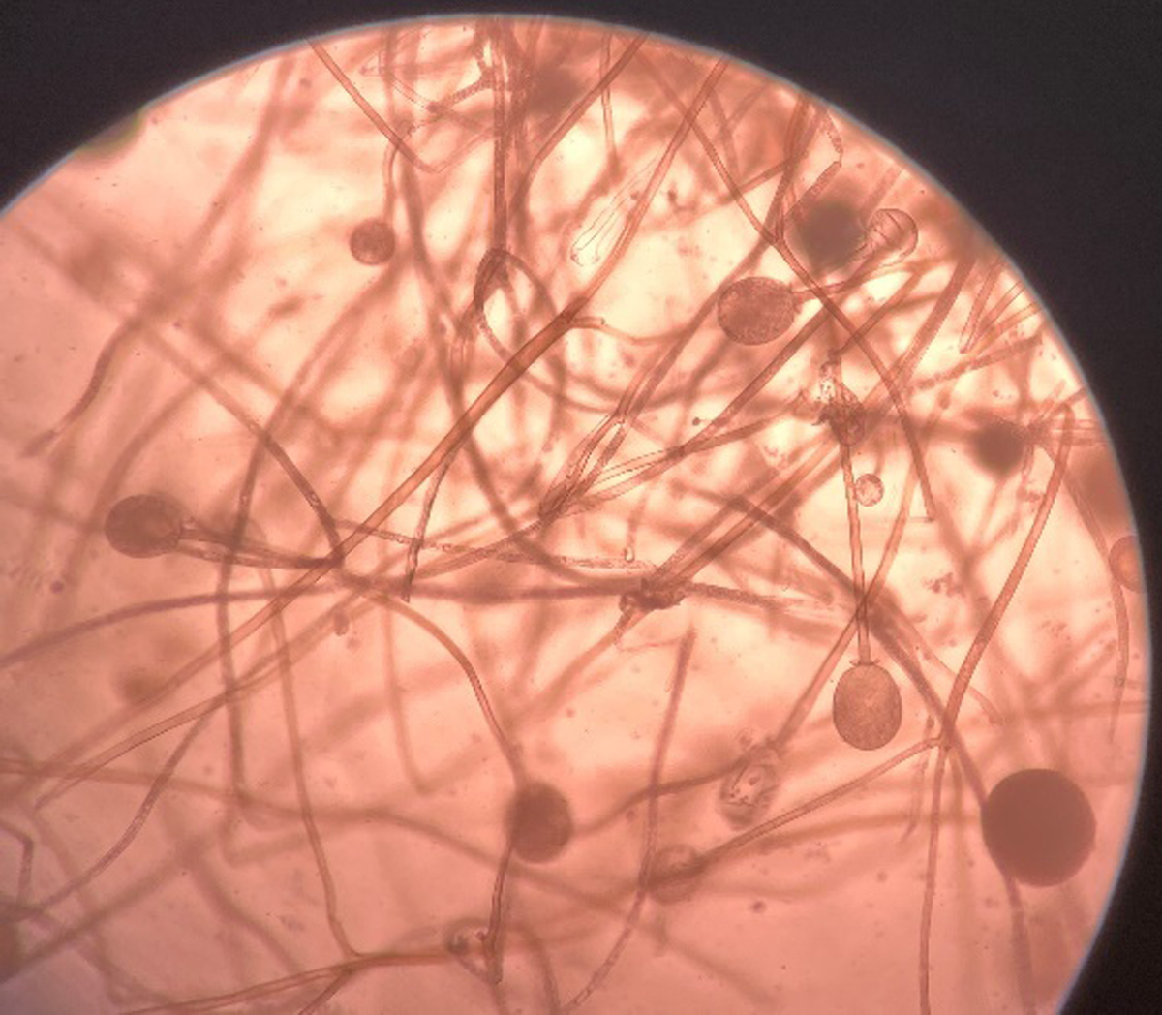

Supplementary figure 2. KOH mount showing broad aseptate hyphae of Mucorales with fruiting bodies
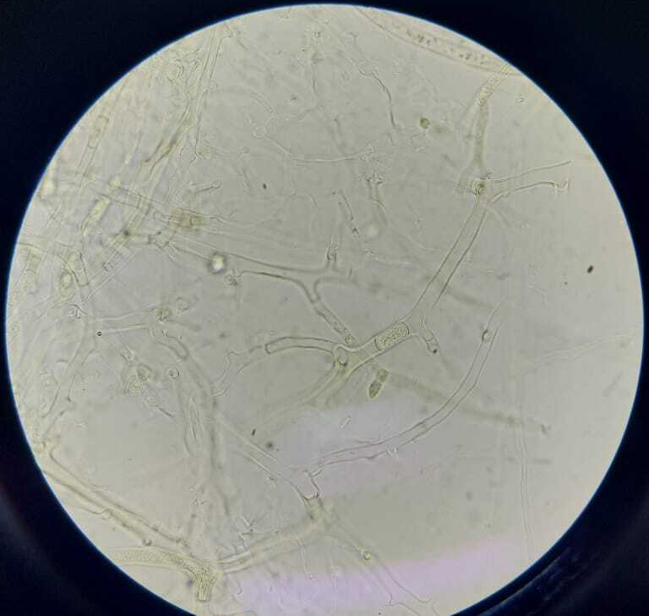

Supplementary figure 1. KOH mount showing broad aseptate hyphae with wide angle branching
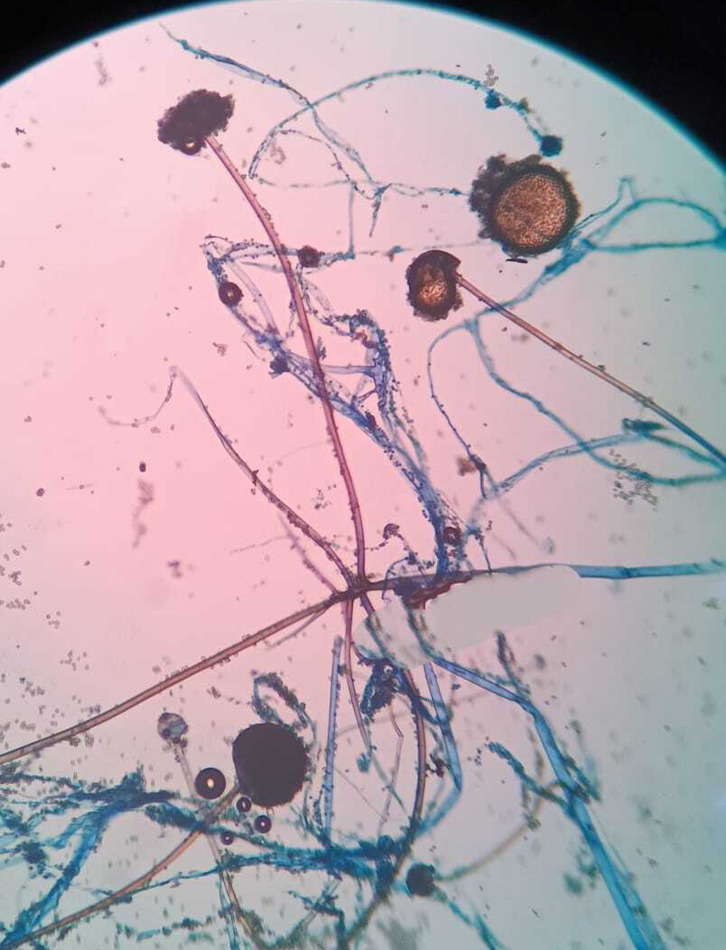

Supplementary figure 4. Lactophenol Cotton Blue (LPCB) mount showing Syncephalastrum racemosum
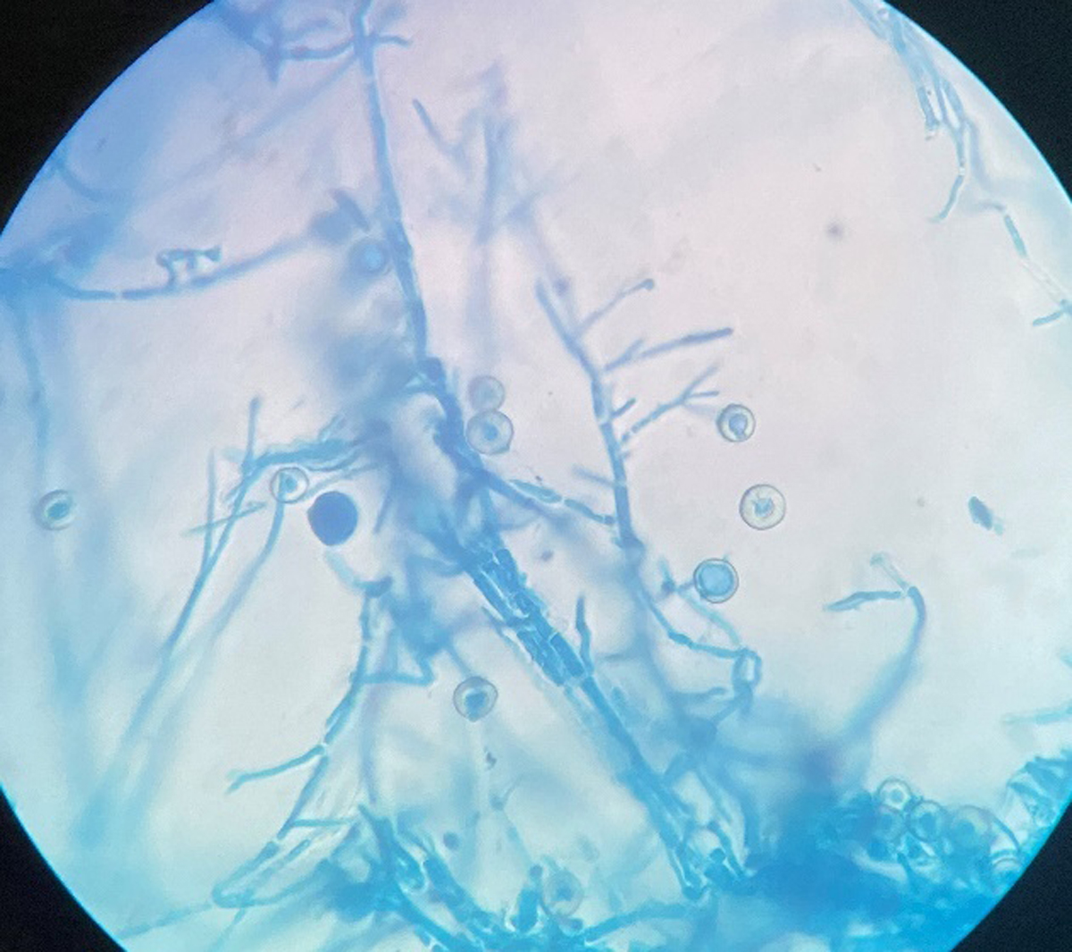

Supplementary figure 3. Lactophenol Cotton Blue (LPCB) mount showing Hülle cells of Aspergillus nidulans

